
PRACTICAL TRAINING REPORT
at
NAME OF ORGANISATION
STUDENT NAME
STUDENT ID
UNIVERSITI TEKNOLOGI MARA

PRACTICAL TRAINING REPORT

At

Name of Organisation
Full address of organisation (line1)
Full address of organisation (line2)

17 March - 29 August 2025

STUDENT NAME
STUDENT ID

Report submitted in partial fulfilment of the requirement
for the degree of
Diploma in Computer Science

College of Computing, Informatics and Mathematics
UiTM Johor Branch

August 2025

Approved by:

Name: ACADEMIC SUPERVISOR’S NAME

Department: College of Computing, Informatics and Mathematics,
UiTM Johor Branch

Signature:

Date:

ACKNOWLEDGEMENT

Students may include a brief statement of appreciation in recognition of any special assistance rendered to them by any person or entity during the whole Practical Training duration.
The texts in these paragraphs are formatted using the “C Body Text” style for correct formatting. Students should replace these sample texts with their own texts.

TABLE OF CONTENTS
Page
ACKNOWLEDGEMENT iii
TABLE OF CONTENTS iv
LIST OF TABLES vi
LIST OF FIGURES vii
ABSTRACT viii
ABSTRAK ix
CHAPTER 1: INTRODUCTION TO PRACTICAL TRAINING 1
1.1. Introduction 1
CHAPTER 2: ORGANISATION BACKGROUND 2
2.1. Replace This Section Title with the Official Name of Organisation 2
2.2. Replace This Section Title with the Name of Branch (OR Delete This Whole Section If Not Applicable) 2
2.3. Replace This Section Title with the Name of Attached Department (OR Delete This Whole Section If Not Applicable) 2
2.4. Vision & Mission 3
2.5. Organisational Structure 3
2.6. Location of Organisation 3
2.7. Describe the Other Details of Organisation (If Applicable) 3
CHAPTER 3: PROJECTS AND TASKS 4
3.1. Project 1: Replace This Section Title with the Name of Project 1 4
3.1.1. Problem Statement 4
3.1.2. Objective 4
3.1.3. Scope and Requirements 4
3.1.4. Tools Used 4
3.1.5. Project Planning 4
3.1.6. Project Analysis and Design 5
3.1.7. Project Implementation 6
3.1.8. Project Testing 6
3.1.9. Results and Discussion 7
3.2. Project 2: Replace This Section Title with the Name of Project 2 7
3.2.1. Problem Statement 7
3.2.2. Objective 7
3.2.3. Scope and Requirements 7
3.2.4. Tools Used 8
3.2.5. Project Planning 8
3.2.6. Project Analysis and Design 9
3.2.7. Project Implementation 9
3.2.8. Project Testing 10
3.2.9. Results and Discussion 10
3.3. Project 3: Replace This Section Title with the Name of Project (OR Delete This Whole Section If Not Applicable) 10
3.4. Miscellaneous Tasks 13
3.4.1. Replace This Section Title with the Name of Task 1 13
3.4.2. Replace This Section Title with the Name of Task 2 13
3.4.3. Replace This Section Title with the Name of Task 3 13
3.4.4. Replace This Section Title with the Name of Task 4 (OR Delete This Whole Section If Not Applicable) 13
3.4.5. Replace This Section Title with the Name of Task 5 (OR Delete This Whole Section If Not Applicable) 13
3.4.6. Replace This Section Title with the Name of Task 6 (OR Delete This Whole Section If Not Applicable) 14
3.4.7. Replace This Section Title with the Name of Task 7 (OR Delete This Whole Section If Not Applicable) 14
3.4.8. Replace This Section Title with the Name of Task 8 (OR Delete This Whole Section If Not Applicable) 14
CHAPTER 4: DISCUSSION 15
4.1. Discussion 15
4.2. Reflection on Personal Improvement During the Practical Training 15
CHAPTER 5: CONCLUSION AND SUGGESTION 17
5.1. Conclusion 17
5.2. Suggestion 17
REFERENCES 18
APPENDIX A: PRACTICAL TRAINING LOGBOOK 20
APPENDIX B: ADDITIONAL FIGURES OR TABLE (OPTIONAL) 25
APPENDIX C: HOW TO CHANGE THE APPENDIX LABEL 26

LIST OF TABLES
Page
Table 3.1 Example of table in Practical Training Report 11

LIST OF FIGURES
Page
Figure 2.1 Sample image of organisation. 2
Figure 2.2 Sample of organisational chart. 3
Figure 3.1 Sample of Gantt chart for Project 1. 5
Figure 3.2 Sample of flowchart for Project 1. 6
Figure 3.3 Sample of Gantt chart for Project 2. 8
Figure 3.4 Example of storyboard for Project 2 (Canva, n.d.). 9
Figure 3.5 Update table numbering. 11
Figure 3.6 Update figure numbering. 12
Figure 3.7 Update equation numbering. 12

ABSTRACT

Abstract is a summary of the whole Practical Training report. The abstract should have summary of every chapter in the report. This abstract then need to be translated to Bahasa Melayu in the next section (Abstrak). The abstract should not exceed 500 words and is written in one (1) paragraph only. Generally, the contents of abstract in English tend to have less words than the contents for Abstrak in Bahasa Melayu.
ABSTRACT IS THE LAST THING TO WRITE IN EVERY REPORT. Starting to write report from abstract mean that the report will never finish.

ABSTRAK

Abstrak ialah satu bentuk penulisan yang merumuskan keseluruhan laporan Latihan Praktik ini dalam Bahasa Melayu. Abstrak perlu mengandungi rumusan dari setiap bab dalam laporan ini. Abstrak ini merupakan terjemahan kepada kandungan dalam bahagian sebelum ini, iaitu Abstract dalam Bahasa Inggeris. Panjang abstrak haruslah tidak melebihi 500 patah perkataan, dan ditulis dalam satu (1) perenggan sahaja. Secara umumnya, kandungan abstrak dalam Bahasa Melayu akan lebih panjang dari kandungan abstract dalam Bahasa Inggeris.

INTRODUCTION TO PRACTICAL TRAINING

Introduction
In CHAPTER 1. INTRODUCTION TO PRACTICAL TRAINING, students are supposed to introduce the CSC339 Practical Training course. The CSC339 course is a compulsory course for CDCS110 Diploma in Computer Science Programme at Universiti Teknologi MARA Johor Branch.
Students should only explain about the Practical Training course in this chapter. Students may mention the name of the organisation they are attached at for Practical Training, but do not discuss about the organisation in Chapter 1.
All texts in paragraphs should be formatted using the “C Body Text” style for correct formatting. Students should replace these sample texts with their own texts. The “C Body Texts” style should be used for correct formatting of all paragraphs in the Practical Training Report.
The “C Bullet and Number Text” style should be used for bulleted or numbered lists in the text, so that the spacing for bulleted and numbered lists is correct.
- The “C Body Texts” style applies the double-spacing between paragraphs.
- The “C Bullet Text” style does not apply the double-spacing between paragraphs.

ORGANISATION BACKGROUND

Replace This Section Title with the Official Name of Organisation
In CHAPTER 2. ORGANISATION BACKGROUND, students are supposed to describe the organisation they are attached to. This description may include a brief history of the organisation or how the organisation was established.

Figure 2.1 Sample image of organisation.

Replace This Section Title with the Name of Branch (OR Delete This Whole Section If Not Applicable)
If a student is attached to a branch office of an organisation, student should describe the background of the branch they are attached to. Students also may list down the other branches of the organisation.

Replace This Section Title with the Name of Attached Department (OR Delete This Whole Section If Not Applicable)
If a student is attached to a department in a branch office of an organisation, student should describe the details of the department they are attached to. Students also may list down the other departments in the branch they are attached to.
If a student is attached to a department of an organisation (without branch), student should describe the details of the department they are attached to. Students also may list down the other departments in the organisation they are attached to.

Vision & Mission
Students should list down the vision and missions of the organisation they are attached to, if available.

Organisational Structure
Students should provide an organisational structure of the organisation they are attached at, if available.
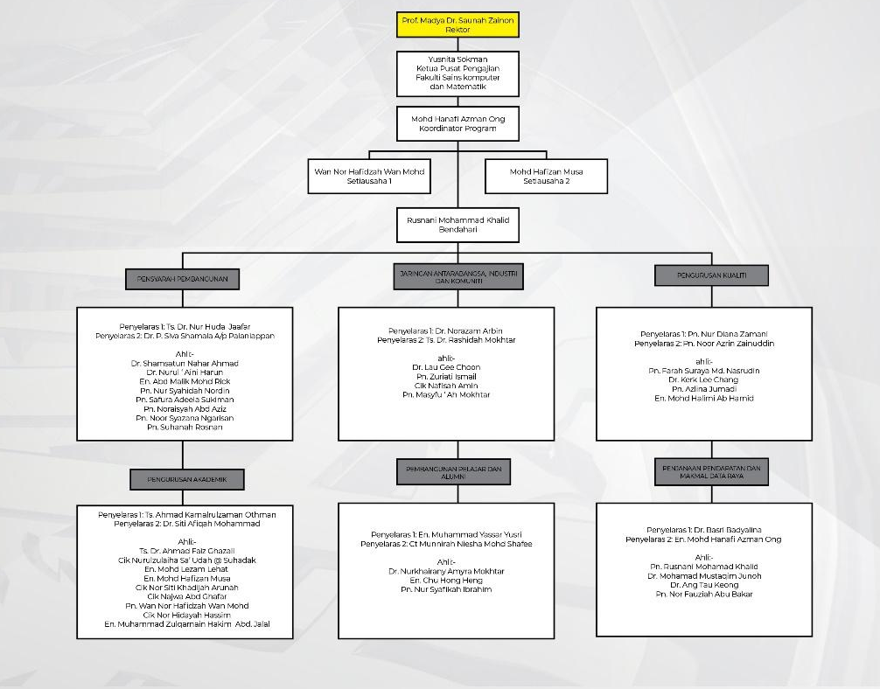
Figure 2.2 Sample of organisational chart.

Location of Organisation
Student should describe where the organisation is located, including the address. Students should also provide a location map of the organisation they are attached at, if available.

Describe the Other Details of Organisation (If Applicable)
Students may include other information of the organisation they are attached to, if applicable/available. (e.g. operating hours, client charter, motto, website, etc)

PROJECTS AND TASKS

Project 1: Replace This Section Title with the Name of Project 1
Students should briefly introduce and describe the Project 1 assigned to them during Practical Training. Students should also provide a duration when this project take place.

Problem Statement
Students should describe the issues that Project 1 attempts to solve.

Objective
Students should describe the objectives of Project 1 based on the problem statement.

Scope and Requirements
Students should describe the specific scope or limitations or assumptions made for Project 1. Students should also describe the specific requirements imposed on Project 1

Tools Used
Students should list and describe the tools (hardware and software) used to implement Project 1.

Project Planning
Students should describe the planning done for Project 1. The system development lifecycle (SDLC) is a very useful concept for planning any project, not only limited to system development. Gantt chart is a very useful tool for planning phase for planning phase. Figure 3.1 shows an example of Gantt chart that should be included as part of planning for Project 1.
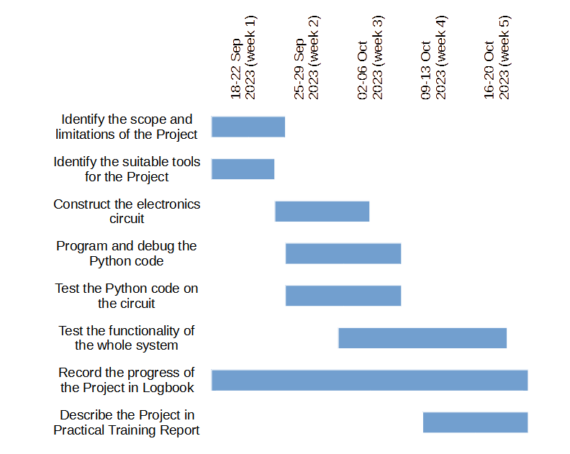
Figure 3.1 Sample of Gantt chart for Project 1.

Project Analysis and Design
Students should describe the analysis done to meet the requirements and limitations for Project 1. Students should also describe a design of how they plan to implement Project 1 until completion. For projects related to system development, a flow chart should be included as part of the design phase; for projects related to multimedia, a storyboard or similar tool should be included as part of the design phase.
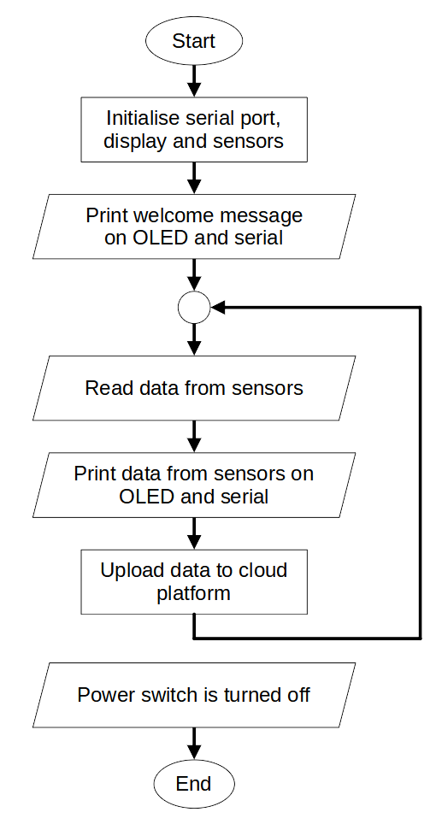
Figure 3.2 Sample of flowchart for Project 1.

Project Implementation
Students should describe in detail the steps, tasks, modules, etc. that was developed to implement Project 1. This implementation phase should reflect the design phase. Students may also describe the mistakes they had made during the implementation phase and what were done rectify the mistakes.
Student are encouraged to insert figures and tables to assist in describing the implementation of Project 1.

Project Testing
Students should describe and visualise how they conduct the testing for Project 1. Example 1, testing for multimedia project will usually involve the presentation of the project to the audience. Example 2, system development projects will usually involve testing every module within the developed system, including corner cases.
Student are encouraged to insert figures and tables to assist in describing the testing of Project 2

Results and Discussion
Students should present the outcomes or results from implementation of Project 1. Students should discuss the problems they encountered while implementing Project 1 and the steps taken to solve those problems.
Students should discuss the benefits of the Project 1 to the organisation, UiTM or the community.

Project 2: Replace This Section Title with the Name of Project 2
Students should briefly introduce and describe the Project 2 assigned to them during Practical Training. Students should also provide a duration when this project take place.

Problem Statement
Students should describe the issues that Project 2 attempts to solve.

Objective
Students should describe the objectives of Project 2 based on the problem statement.

Scope and Requirements
Students should describe the specific scope or limitations or assumptions made for Project 2. Students should also describe the specific requirements imposed on Project 2

Tools Used
Students should list and describe the tools (hardware and software) used to implement Project 2.

Project Planning
Students should describe the planning done for Project 2. The system development lifecycle (SDLC) is a very useful concept for planning any project, not only limited to system development. Gantt chart is a very useful tool for planning phase. Figure 3.3 shows an example of Gantt chart that should be included as part of planning for Project 2.
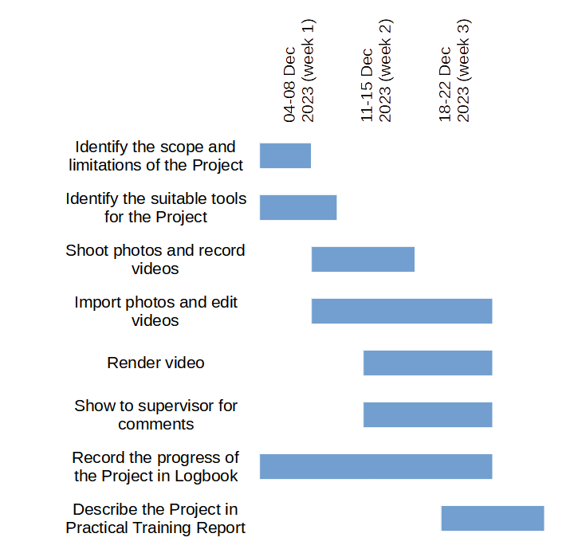
Figure 3.3 Sample of Gantt chart for Project 2.

Project Analysis and Design
Students should describe the analysis done to meet the requirements and limitations for Project 2. Students should also describe a design of how they plan to implement Project 2 until completion. For projects related to system development, a flow chart should be included as part of the design phase; for projects related to multimedia, a storyboard or similar tool should be included as part of the design phase.
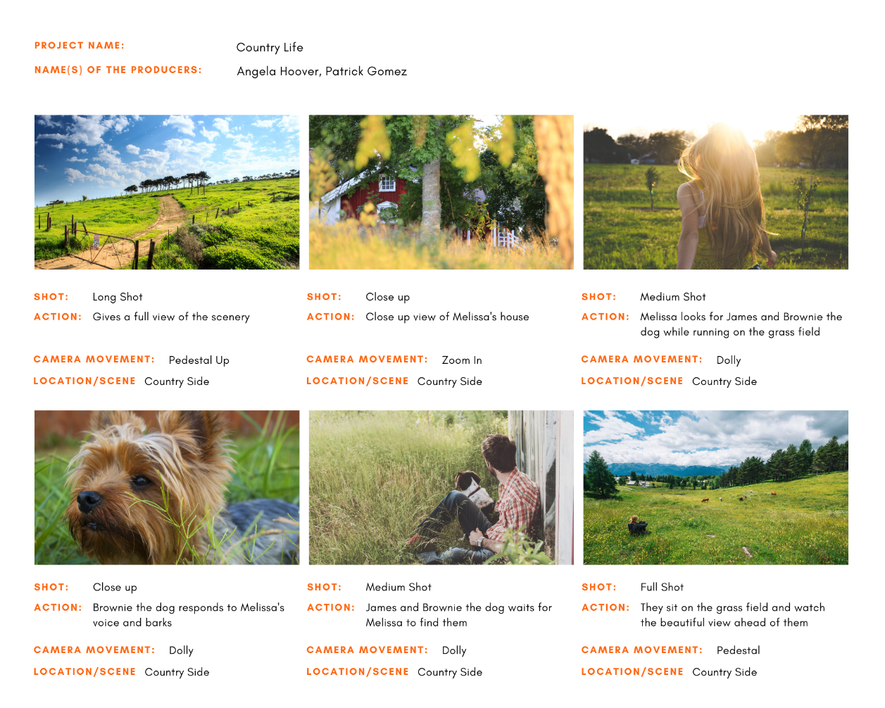
Figure 3.4 Example of storyboard for Project 2 (Canva, n.d.).

Project Implementation
Students should describe in detail the steps, tasks, modules, etc. that was developed to implement Project 2. This implementation phase should reflect the design phase. Students may also describe the mistakes they had made during the implementation phase and what were done rectify the mistakes.
Student are encouraged to insert figures and tables to assist in describing the implementation of Project 2.

Project Testing
Students should describe and visualise how they conduct the testing for Project 2. Example 1, testing for multimedia project will usually involve the presentation of the project to the audience. Example 2, system development projects will usually involve testing every module within the developed system, including corner cases.
Student are encouraged to insert figures and tables to assist in describing the testing of Project 2

Results and Discussion
Students should present the outcomes or results from implementation of Project 2. Students should discuss the problems they encountered while implementing Project 2 and the steps taken to solve those problems.
Students should discuss the benefits of the Project 2 to the organisation, UiTM or the community.

Project 3: Replace This Section Title with the Name of Project (OR Delete This Whole Section If Not Applicable)
Students may add more sections in Chapter 3 to discuss all projects or tasks assigned to them during Practical Training.
For every project and tasks, students are encouraged to insert photos, figures, diagrams, tables or equations to assist in describing the project.
Below is an example of table and table caption, with the correct formatting. Students can copy the table and its table caption to be inserted into their Practical Training Report. Students then can change the example table with their own table, and change the table caption with a suitable description. The table number will update accordingly after students highlight it, right-click and choose “Update Field” as shown in Figure 3.5.
Table 3.1 Example of table in Practical Training Report
No. | Item | Description
1 | Style | Use the “C Chapter Table & Caption” style to apply the correct formatting for the table caption.
2 | Formatting of texts in table | Students may change the formatting of texts in a table for suitable appearance.
3 | Spacing of texts in table | Texts in a table should be single-spaced.
4 | Update table caption number | Highlight the table caption, right-click and choose “Update Field”.

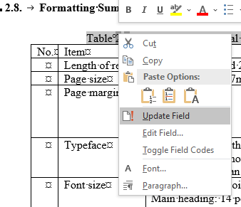
Figure 3.5 Update table numbering.

Below is an example of figure and figure caption, with the correct formatting. Students can copy the figure and its figure caption to be inserted into their Practical Training Report. Students then can change the example figure with their own figure, and change the figure caption with a suitable description. The figure number will update accordingly after students highlight it, right-click and choose “Update Field”, as shown in Figure 3.6.
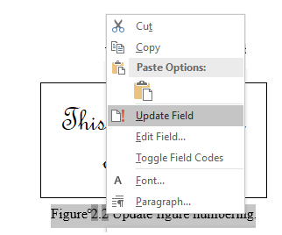
Figure 3.6 Update figure numbering.

Below is an example of how an equation and equation numbering should appear in the Practical Training Report. For correct formatting, the equation and equation caption are inserted into a table with invisible border.
$y=\frac{-b±\sqrt{b^{2}-4ac}}{2a}$ | (3.1)
Students can copy the example equation to be inserted into their Practical Training Report. Students then can change the example equation with their own equation. The equation number will update accordingly after students highlight it, right-click and choose “Update Field”, as shown in Figure 3.7.

Figure 3.7 Update equation numbering.

Miscellaneous Tasks
Students should list and describe the other miscellaneous tasks assigned to them during the Practical Training. This section can be divided into subsections to describe every miscellaneous task if necessary.
Daily routine tasks should also be included in this section.

Replace This Section Title with the Name of Task 1
Students should describe the miscellaneous task assign to them. Student should insert figures and tables if necessary to assist in describing the assigned tasks.

Replace This Section Title with the Name of Task 2
Students should describe the miscellaneous task assign to them. Student should insert figures and tables if necessary to assist in describing the assigned tasks.

Replace This Section Title with the Name of Task 3 (OR Delete This Whole Section If Not Applicable)
Students should describe the miscellaneous task assign to them. Student should insert figures and tables if necessary to assist in describing the assigned tasks.

Replace This Section Title with the Name of Task 4 (OR Delete This Whole Section If Not Applicable)
Students should describe the miscellaneous task assign to them. Student should insert figures and tables if necessary to assist in describing the assigned tasks.

Replace This Section Title with the Name of Task 5 (OR Delete This Whole Section If Not Applicable)
Students should describe the miscellaneous task assign to them. Student should insert figures and tables if necessary to assist in describing the assigned tasks.

Replace This Section Title with the Name of Task 6 (OR Delete This Whole Section If Not Applicable)
Students should describe the miscellaneous task assign to them. Student should insert figures and tables if necessary to assist in describing the assigned tasks.

Replace This Section Title with the Name of Task 7 (OR Delete This Whole Section If Not Applicable)
Students should describe the miscellaneous task assign to them. Student should insert figures and tables if necessary to assist in describing the assigned tasks.

Replace This Section Title with the Name of Task 8 (OR Delete This Whole Section If Not Applicable)
Students should describe the miscellaneous task assign to them. Student should insert figures and tables if necessary to assist in describing the assigned tasks.

DISCUSSION

Discussion
In this chapter students are supposed to discuss about the new technical knowledge, skills, experiences, and other benefits that is gained during the Practical Training at the organisation.
Students may discuss and reflect on how the new knowledge, skills, experiences, and other benefits enhances their understanding of courses taken during their study in Diploma in Computer Science.
Students may also reflect on how the new knowledge, skills, experiences, and other benefits changes their perspective in the field of computer science or any other fields.

Reflection on Personal Improvement During the Practical Training
During Practical Training, all students will grow a lot from what they previously were when they were in UiTM. Students should reflect on their personal growth during the practical training.
Other than improvements in their technical knowledge, skills or experiences discussed in Section 4.1, all students will also gain other skills and experiences commonly referred to as “soft skills” or “human skills”.
In this section, students should reflect and discuss their personal growth in term of “soft skills” or human skills (kemahiran insaniah) such as effective (verbal and non-verbal) communication, public speaking, effective writing, self-awareness, confidence, empathy, open-mindedness, leadership, coaching, teamwork, cooperation, work ethic, integrity, perseverance, life-long-learning, research, resourcefulness, adaptability to change, taking calculated risks, etc. These are the skills that cannot be taught in a classroom environment; but can only be learnt through personal experiences.
Students may add more sections in Chapter 4 to discuss other benefits that is gained during Practical Training, if necessary.

CONCLUSION AND SUGGESTION

Conclusion
In Chapter 5, students are supposed to conclude their Practical Training Report. When concluding the Practical Training Report, students may briefly describe the benefits they have gained from the assigned project/tasks, from the organisation, and from the Practical Training in general.

Suggestion
Students should be able to provide some suggestion on how to improve the CSC339 Practical Training course or Practical Training Experience at the organisation in the future.

REFERENCES

Ahmed, T., Cox, J., Girvan, L., Paul, A., Paul, D., & Cadle, P. T. J. (2014) Developing Information Systems. BCS, The Chartered Institute for IT.
Canva (n.d.). Green and White Grid Panel Storyboard [Online image]. Canva. https://www.canva.com/templates/EADajsIXPEY-green-and-white-grid-panel-storyboard/
Kendall, K. E. & Kendall, J. E. (2014). System Analysis and Design (9th ed.). Pearson.
Stair, R. & Reynolds, G. (2014). Principles of Information Systems (11th ed.). Cengage Learning.
Stair, R. & Reynolds, G. (2017). Fundamentals of Information Systems (9th ed.). Cengage Learning.
Tilley, S., & Rosenblatt, H. J. (2016). Systems Analysis and Design (11th ed.). Cengage Learning.
(These references are example of references formatted in American Psychological Association (APA) format.)
(Refer to https://apastyle.apa.org/ for guides on how to references of different sources are formatted)
(Student should replace these examples with your own references)

APPENDICES

APPENDIX A: PRACTICAL TRAINING LOGBOOK
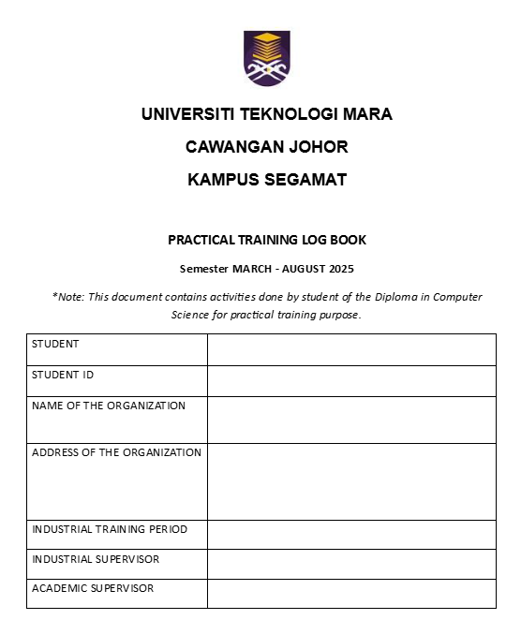

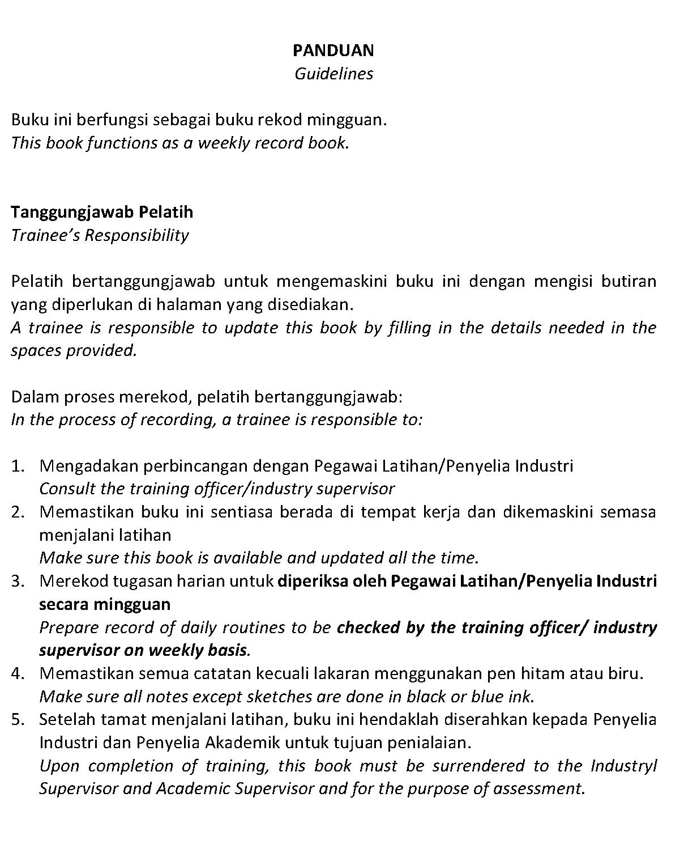
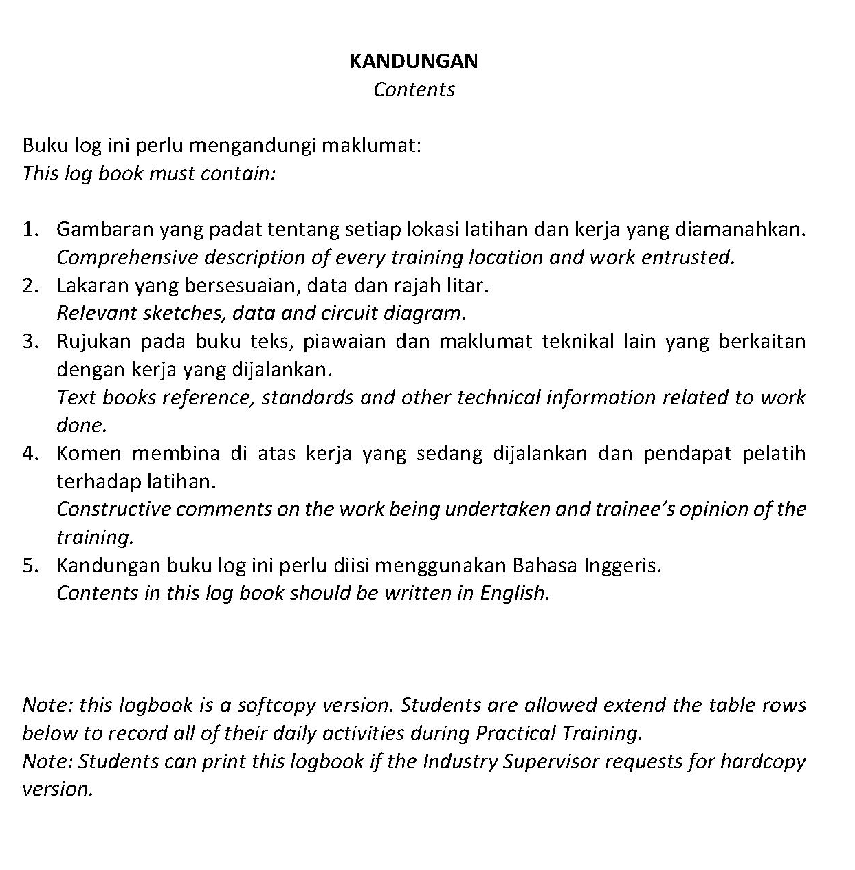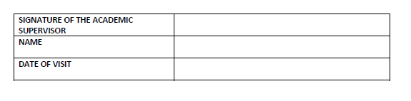

The Academic Supervisor must approve the logbook by signing here.
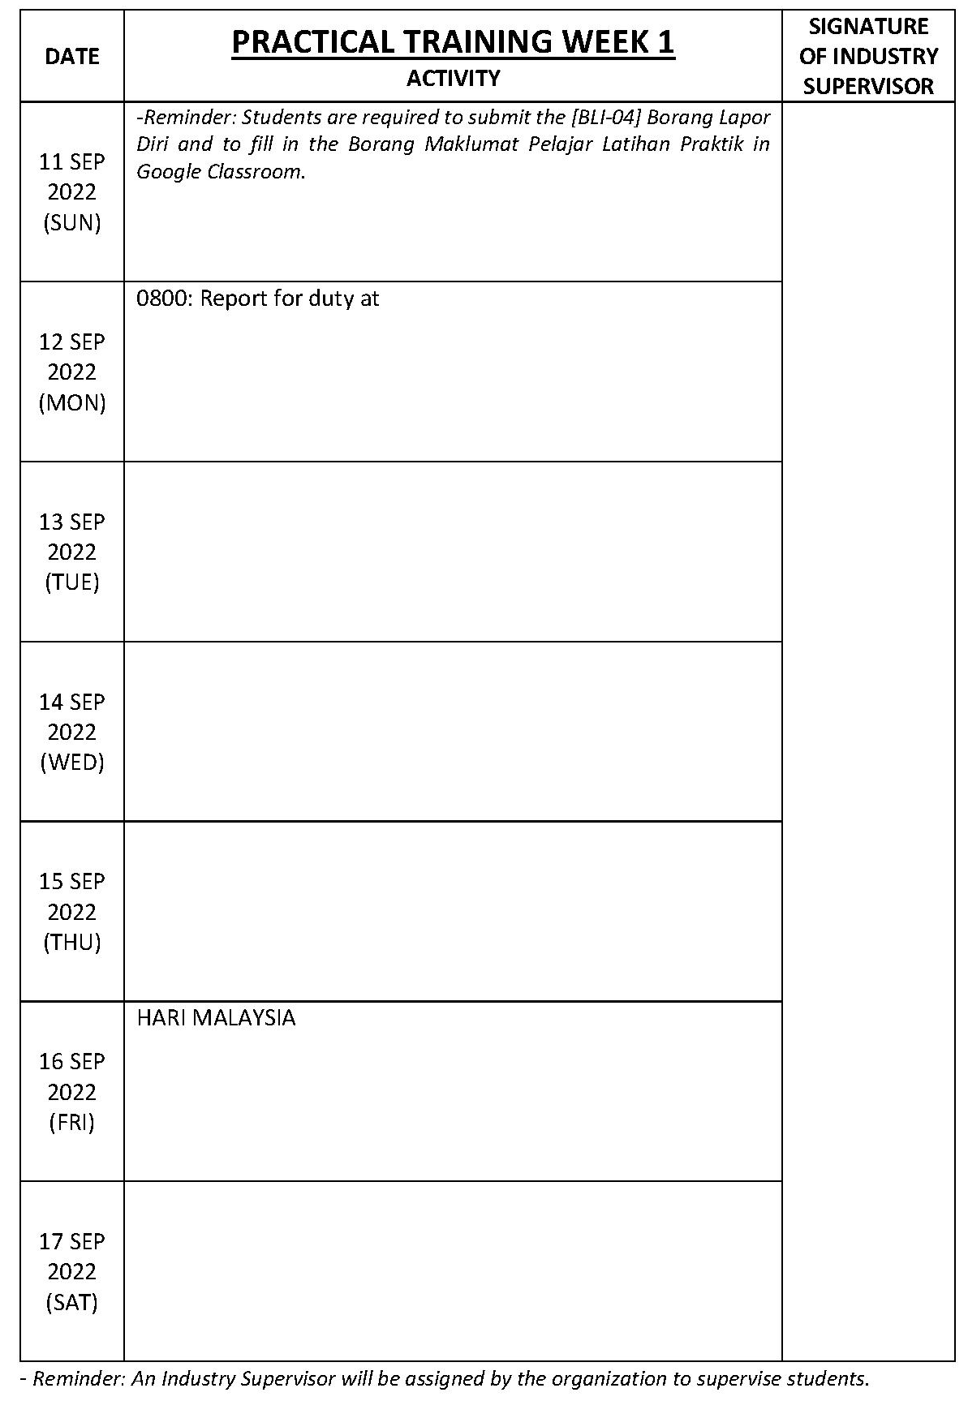

The Industry Supervisor must approve the logbook by signing here with official stamp every week.
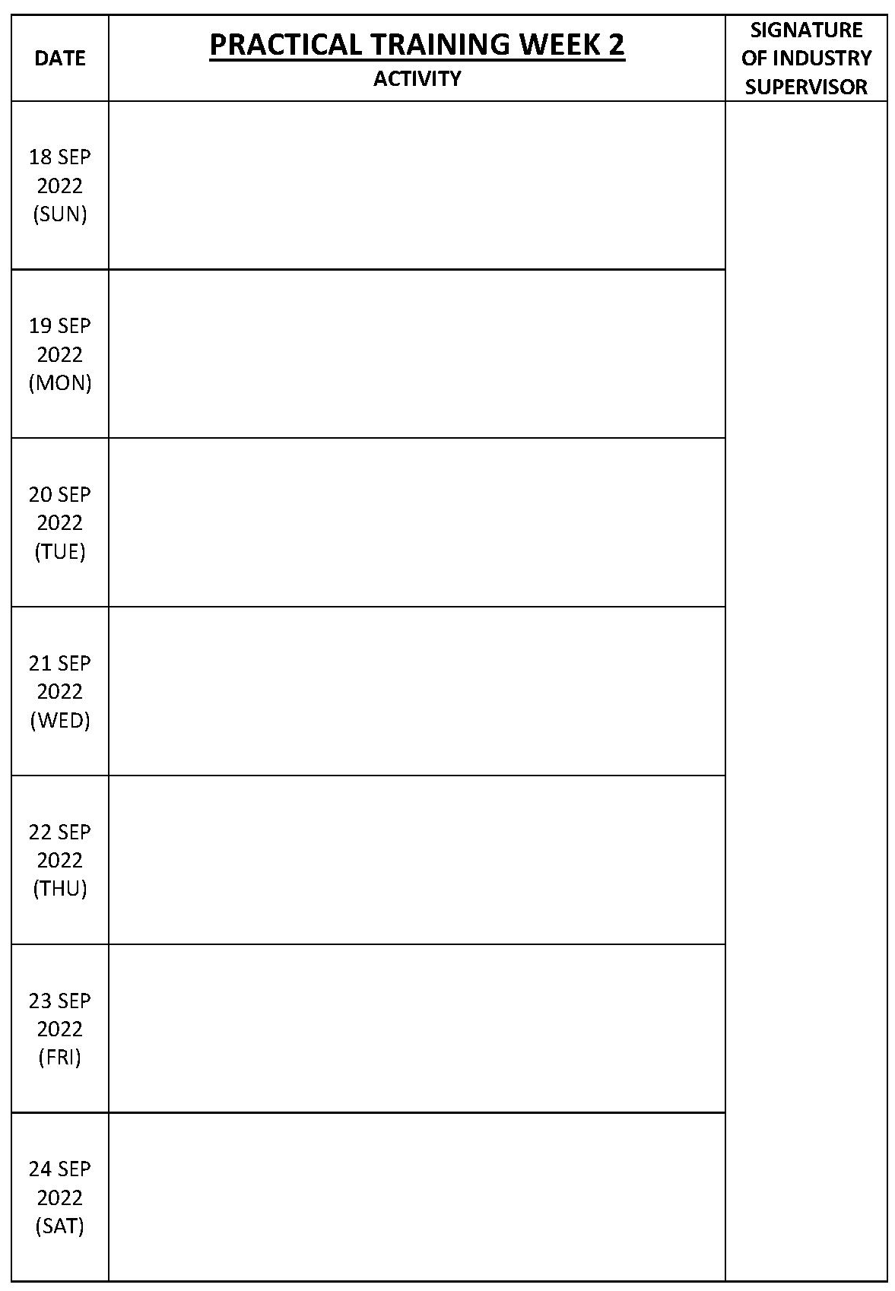

The Industry Supervisor must approve the logbook by signing here with official stamp every week.
The logbook attached in Appendix A must be until week 20 of Practical Training.

APPENDIX B: ADDITIONAL FIGURES OR TABLE (OPTIONAL)
Additional figures that is not included in the main body (chapter) of the Practical Training Report can be inserted in the appendix. Additional figures that help to describe other miscellaneous tasks performed during practical training can be included in appendix.
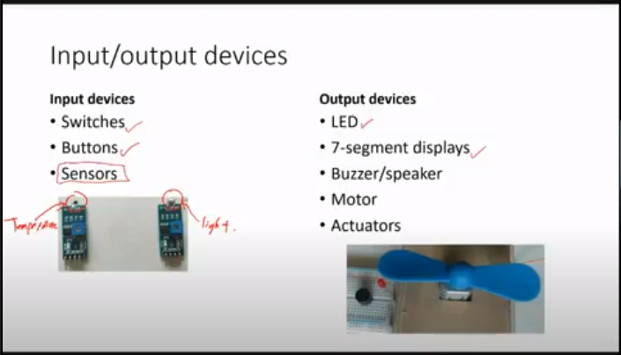
Additional figures and tables included in Appendix must be captioned, but not numbered.

APPENDIX C: HOW TO CHANGE THE APPENDIX LABEL
Use sections breaks to separate appendices into separate sections. Students can only change the appendix label at the top right-hand margin of the page using sections breaks.
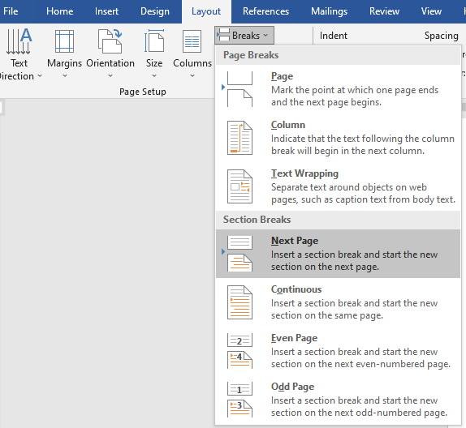
Use sections breaks to separate appendices into separate sections.
To change the appendix labels, first, double click the header portion of the page to activate the edit Header/Footer menu. Then deselect the “Link to Previous” option under the Header & Footer tab. Change the appendix labels to match the current appendix page.
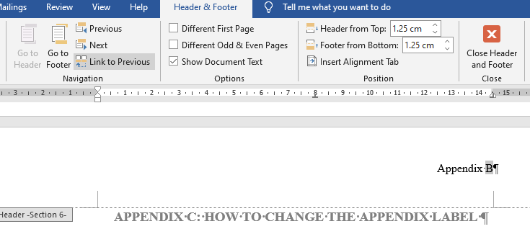
Deselect the “Link to Previous” option.

